#### ***Seat Heater***

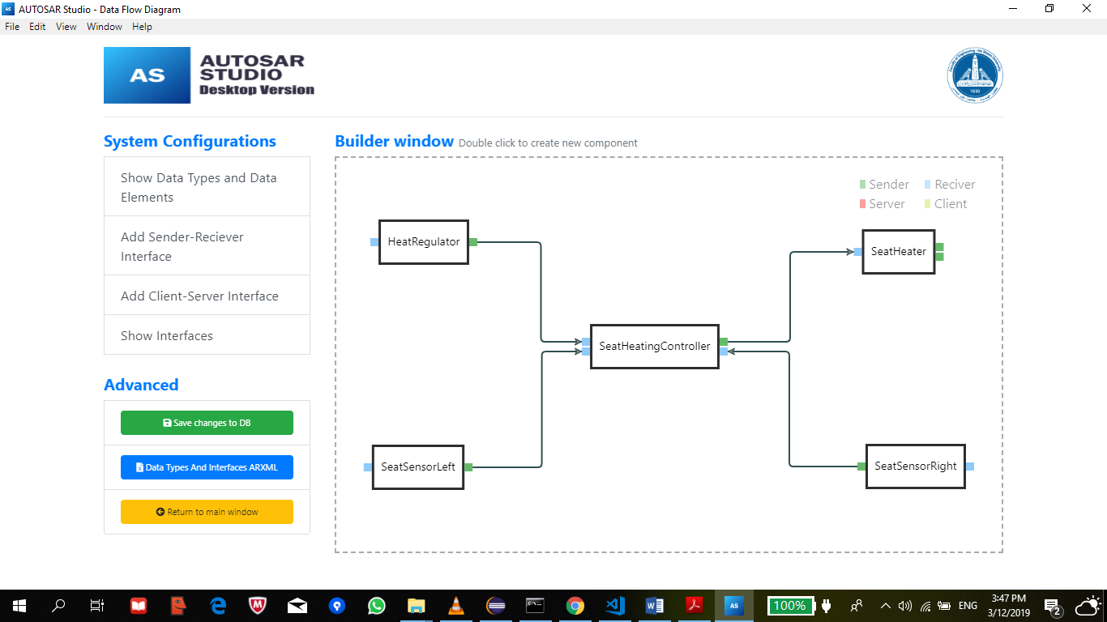

|  |  |
| --- | --- |
| SWC | HeatRegulator |
| **Port Name** | **Position** |
| **Port Type** | **P-Port (Sender)** |
| **Port Position** | **Right** |
| **Port Interface** | **RegulatorPosition** |
| **Data Element Name** | **Position** |
| **Data Element Type** | **UnsignedInteger_32** |

|  |  |
| --- | --- |
| SWC | HeatRegulator |
| **Port Name** | **RegulatorIO** |
| **Port Type** | **R-Port (Receiver)** |
| **Port Position** | **Left** |
| **Port Interface** | **RegulatorIOInterface** |
| **Data Element Name** | **RegulatorValue** |
| **Data Element Type** | **UnsignedInteger_32** |

|  |  |
| --- | --- |
| SWC | SeatHeaterLeft |
| **Port Name** | **StatusLeft** |
| **Port Type** | **P-Port (Sender)** |
| **Port Position** | **Right** |
| **Port Interface** | **LeftSeatStatusInterface** |
| **Data Element Name** | **PassengerOnLeftSeat** |
| **Data Element Type** | **Boolean** |

|  |  |
| --- | --- |
| SWC | SeatHeaterLeft |
| **Port Name** | **SensorLeftIO** |
| **Port Type** | **R-Port (Receiver)** |
| **Port Position** | **Left** |
| **Port Interface** | **LeftSensorIOInterface** |
| **Data Element Name** | **LeftSensorValue** |
| **Data Element Type** | **Boolean** |

|  |  |
| --- | --- |
| SWC | SeatHeater |
| **Port Name** | **RightSeaterIO** |
| **Port Type** | **P-Port (Sender)** |
| **Port Position** | **Right** |
| **Port Interface** | **RightSeatHeaterIOInterface** |
| **Data Element Name** | **RightHeaterValue** |
| **Data Element Type** | **UnsignedInteger_32** |

|  |  |
| --- | --- |
| SWC | SeatHeater |
| **Port Name** | **LeftSeaterIO** |
| **Port Type** | **P-Port (Sender)** |
| **Port Position** | **Right** |
| **Port Interface** | **LeftSeatHeaterIOInterface** |
| **Data Element Name** | **LeftHeaterValue** |
| **Data Element Type** | **UnsignedInteger_32** |

|  |  |
| --- | --- |
| SWC | SeatHeater |
| **Port Name** | **Levels** |
| **Port Type** | **R-Port (Receiver)** |
| **Port Position** | **Left** |
| **Port Interface** | **HeaterLevel** |
| **Data Element Name** | **LeftHeaterLevel** |
| **Data Element Name** | **RightHeaterLevel** |
| **Data Element Type** | **UnsignedInteger_32** |

|  |  |
| --- | --- |
| SWC | SeatSensorRight |
| **Port Name** | **StatusRight** |
| **Port Type** | **P-Port (Sender)** |
| **Port Position** | **Left** |
| **Port Interface** | **RightSeatStatusInterface** |
| **Data Element Name** | **PassengerOnRightSeat** |
| **Data Element Type** | **Boolean** |

|  |  |
| --- | --- |
| SWC | SeatSensorRight |
| **Port Name** | **StatusRightIO** |
| **Port Type** | **R-Port (Receiver)** |
| **Port Position** | **Right** |
| **Port Interface** | **RightSensorIOInterface** |
| **Data Element Name** | **RightSensorValue** |
| **Data Element Type** | **Boolean** |

|  |  |
| --- | --- |
| SWC | SeatHeatingController |
| **Port Name** | **RightSeatStatus** |
| **Port Type** | **R-Port (Receiver)** |
| **Port Position** | **Right** |
| **Port Interface** | **RightSeatStatusInterface** |
| **Data Element Name** | **PassengerOnRightSeat** |
| **Data Element Type** | **Boolean** |

|  |  |
| --- | --- |
| SWC | SeatHeatingController |
| **Port Name** | **LeftSeatStatus** |
| **Port Type** | **R-Port (Receiver)** |
| **Port Position** | **Left** |
| **Port Interface** | **LeftSeatStatusInterface** |
| **Data Element Name** | **PassengerOnLeftSeat** |
| **Data Element Type** | **Boolean** |

|  |  |
| --- | --- |
| SWC | SeatHeatingController |
| **Port Name** | **RegulatorPosition** |
| **Port Type** | **R-Port (Receiver)** |
| **Port Position** | **Left** |
| **Port Interface** | **RegulatorPosition** |
| **Data Element Name** | **Position** |
| **Data Element Type** | **UnsignedInteger_32** |

|  |  |
| --- | --- |
| SWC | SeatHeatingController |
| **Port Name** | **HeaterLevels** |
| **Port Type** | **P-Port (Sender)** |
| **Port Position** | **Right** |
| **Port Interface** | **HeaterLevel** |
| **Data Element Name** | **LeftHeatLevevl** |
| **Data Element Name** | **RightHeatLevevl** |
| **Data Element Type** | **UnsignedInteger_32** |